Lab 6: Implementing the API Gateway Pattern
Activity Practice 1: Project Setup and Dependencies
Configure service addresses.
javascript
// src/config/services.js — Configure Microservice URLs
const SERVICES = {
AUTH: 'http://localhost:5001',
PROFILE: 'http://localhost:5002',
PRODUCT: 'http://localhost:5003',
CART: 'http://localhost:5004',
ORDER: 'http://localhost:5005'
};
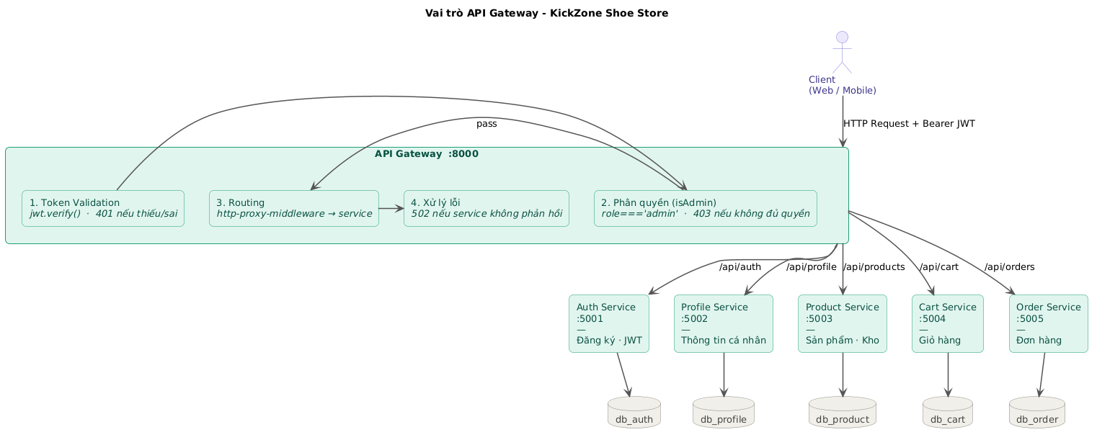

Activity Practice 2: Security and Routing Implementation
1. JWT authentication mechanism at Gateway
The API Gateway is the only place that verifies tokens — the services inside.No self-verification required. again.
Client sends a request with a header:
Authorization: Bearer <JWT_TOKEN>
↓
[API Gateway - auth.js]
jwt.verify(token, JWT_SECRET)
↓
├──Valid token → Decrypt to get { ID, email, role }
│ Attach user information to the internal header:
│ x-user-id, x-user-role, x-user-email
Forward the request to the correct service.
│
└── Invalid token → Returns 401 Unauthorized
2. Access control at Gateway
Middleware check by isAdmin:
↓
├── role === 'admin' →Give the pHandp continues
└── role !== 'admin' → Returns 403 Forbidden
3. Routing Table
Request from Client | Middleware | Go to Service
POST /api/auth/register | No token required. | Auth Service :5001
POST /api/auth/login | No token required. | Auth Service :5001
GET /api/auth/users | authenticate + isAdmin | Auth Service :5001
DELETE /api/auth/users/:id | authenticate + isAdmin | Auth Service :5001
GET /api/profile/:userId | authenticate | Profile Service :5002
PUT /api/profile/:userId | authenticate | Profile Service :5002
GET /api/products | Public | Product Service :5003
GET /api/products/:id | Public | Product Service :5003
POST /api/products | authenticate + isAdmin | Product Service :5003
PUT /api/products/:id | authenticate + isAdmin | Product Service :5003
DELETE /api/products/:id | authenticate + isAdmin | Product Service :5003
GET /api/categories | Public | Product Service :5003
POST /api/categories | authenticate + isAdmin | Product Service :5003
GET /api/brands | Public | Product Service :5003
POST /api/brands | authenticate + isAdmin | Product Service :5003
GET /api/inventory | authenticate + isAdmin | Product Service :5003
GET /api/inventory/low-stock | authenticate + isAdmin | Product Service :5003
GET /api/suppliers | authenticate + isAdmin | Product Service :5003
POST /api/suppliers | authenticate + isAdmin | Product Service :5003
GET /api/imports | authenticate + isAdmin | Product Service :5003
POST /api/imports | authenticate + isAdmin | Product Service :5003
GET /api/cart | authenticate | Cart Service :5004
POST /api/cart | authenticate | Cart Service :5004
PUT /api/cart/:id | authenticate | Cart Service :5004
DELETE /api/cart/:id | authenticate | Cart Service :5004
POST /api/orders | authenticate | Order Service :5005
GET /api/orders/my | authenticate | Order Service :5005
GET /api/orders | authenticate + isAdmin | Order Service :5005
PUT /api/orders/:id/status | authenticate + isAdmin | Order Service :5005
4. Request processing flow through the Gateway
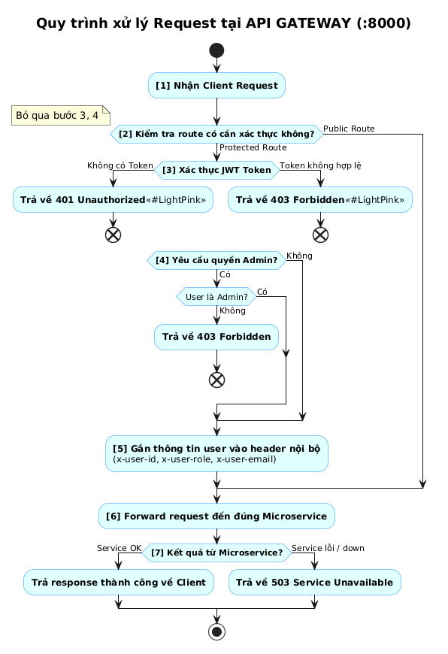
5. Troubleshooting at the Gateway
Situation | HTTP Code | Notification
No token | 401 | The token does not exist.
Incorrect/Expired Token | 403 | Invalid token
Insufficient Admin privileges | 403 | No access
Service is disabled / unresponsive | 503 | Service Unavailable
The route does not exist. | 404 | Not found

Activity Practice 3: Testing the Gateway
Prerequisites before testing
bash
Start all services in this order:
cd auth-service && npm run dev # :5001
cd profile-service && npm run dev # :5002
cd product-service && npm run dev # :5003
cd cart-service && npm run dev # :5004
cd order-service && npm run dev # :5005
cd api-gateway && npm run dev # :8000

Test 1 — Access without token (401)
Request:
bash
curl -X GET http://localhost:8000/api/cart
Expected results: HTTP 401
json
{ "success": false, "message": "Token does not exist." }
Explain:The /api/cart route requires authentication. The gateway blocks it at the middleware authentication stage because there is no authorization header.

Test 2 — Invalid Token (403)
Request:
bash
curl -X GET http://localhost:8000/api/cart \
-H "Authorization: Bearer token_gia_mao"
Expected results: HTTP 403
json
{ "success": false, "message": "Invalid token." }
Explain:The token could not be decrypted using JWT_SECRET; the gateway rejected it.

Test 3 — Log in to get a valid token (200)
Request:
bash
curl -X POST http://localhost:8000/api/auth/login \
-H "Content-Type: application/json" \
-d '{"email":"admin@kickzone.com","password":"admin123"}'
Expected results: HTTP 200
json
{
"success": true,
"token": "eyJhbGciOiJIUzI1NiIsInR...",
"user": { "id": 1, "email": "admin@kickzone.com", "role": "admin" }
}
Explain:The route /api/auth/login is Public, the Gateway forwards directly to Auth Service :5001 without needing to check the token.

Test 4 — Users frequently access the Admin page (403)
Request:
bash
# Log in with a regular user account and get a token.
curl -X POST http://localhost:8000/api/auth/login \
-H "Content-Type: application/json" \
-d '{"email":"user@gmail.com","password":"123456"}'

Use user token to delete product (Admin privileges required)
curl -X DELETE http://localhost:8000/api/products/1 \
-H "Authorization: Bearer <USER_TOKEN>"
Expected results: HTTP 403
json
{ "success": false, "message": "No access." }
Explain:The DELETE route /api/products/:id requests isAdmin. The user's token has the role: 'user', so the Gateway intercepts it before it reaches the Product Service.

Test 5 — Admin successfully accessed (200)
Request:
bash
curl -X GET http://localhost:8000/api/inventory/low-stock \
-H "Authorization: Bearer <ADMIN_TOKEN>"
Expected results: HTTP 200
json
{
"success": true,
"items": [
{ "product_name": "Nike Air Max 270", "size": "43", "quantity": 2 }
]
}
Explain:Valid Admin Token → Gateway successfully authenticates → Forward to Product Service :5003 → Returns a list of products that are out of stock.

Test 6 — Service is off (503)
Request:
bash
Turn off Product Service first.
Then send the request to the Gateway.
curl -X GET http://localhost:8000/api/products
Expected results: HTTP 503
json
{ "success": false, "message": "Product Service did not respond." }
Explain:The gateway attempts to forward to Product Service :5003 but receives no response → Catches a connection error → Returns 503 instead of letting the client receive an unclear error.

Test 7 — View products without a token (Public)
Request:
bash
curl -X GET "http://localhost:8000/api/products?search=Nike&brand_id=1"
Expected results:HTTP 200 — Nike Product List
Explain:The GET route /api/products is Public — the gateway forwards directly to the Product Service without requiring a token.

